W4115 PROGRAMMING LANG & TRANSLATOR

EXGOL LANGUAGE TUTORIAL

Team Name: EXGOL

Team members:
Language and tools guru Suhan Canaran -sc3055@columbia.edu
Project manager Andreas Nilsson - apn2107@columbia.edu
System architect Akshat Sikarwar -as3515@columbia.edu
System integrator Eric Schmidt -es2103@columbia.edu
Tester and validator Aaradhi Tilva -at2577@columbia.edu

Table of Contents
1 Introduction 3
2 Language Purpose 4
2.1 Motivation 4
2.2 Language Scope Decisions 4
2.2.1 Grid Structure 4
2.2.2 Simulation Purpose 5
3 Example Programs 6
3.1 Hello EXGOL 6
3.2 Conway’s Game of Life 8
3.3 Competing Species 9
4 Writing Transition Rules 13
4.1 Anatomy of an EXGOL transition rule 13
4.2 Exercices 15
5 References 18

1 Introduction
The aim of this tutorial is to give a step by step introduction to using the cellular automaton simulation language EXGOL. Since the scope and domain of the language is fairly limited the aim of the tutorial is to be fairly exhaustive. Even so the main focus lies on quickly giving the reader practical experience in working with EXGOL code. For a complete description of EXGOL including grammar see the language reference manual [2].

The tutorial is divided into three main parts. The first part gives an overview of the purpose and scope of EXGOL. It and can be seen as an extension to the motivation. The second and main part consists of a number of commented example programs of increasing complexity. Included in the second part is also a guide to how to compile and run EXGOL programs. To quickly get started with EXGOL simply jump to section 3.1 directly. The third part is a detailed discussion of how to write meaningful EXGOL transition rules.

Since EXGOL describes a simulation there is a fair amount of boiler plate required to for a simple “Hello EXGOL” example. Therefore the tutorial is based on a few example programs with every code statement being described in detail.

2 Language Purpose

2.1 Motivation
A cellular automaton is a mathematical model that consists of a grid of cells, where each cell can be in any of set of states, with an initial configuration specifying the initial state of each cell, and a set of rules that are applied to each cell in the grid to determine its state in the next time-step of the automaton. British mathematician John Conway’s “Game of Life” [1] is a cellular automaton with two states, “alive” or “dead,” and three rules:

1. If alive and have fewer than two live neighbors, die (as if by loneliness)
2. If alive and have more than three live neighbors, die (as if by overcrowding)
3. If dead and have exactly three live neighbors, become alive

This is the most famous cellular automaton. We believe cellular automata may be useful tools for modeling a variety of phenomena, as the game of life suggests they are, and so we would like to make it easy to construct and visualize them. Our programming language aspires to make it very easy to describe and visualize a diverse set of automata, especially automata like the game of life, which have English interpretations.

2.2 Language Scope Decisions

2.2.1 Grid Structure
A grid is simply an n-dimensional set of cells set next to each other. A grid is not a generic graph. In the typical 2-dimensional case for instance grid is a rectangle with m rows and n columns where n and m are chosen by the programmer. In the 1-dimensional case it is a line and in the 3-dimensional case a block. A grid can be either bounded or wrapped. In a bounded grid cells cannot grow outside of the grid whereas in w rapped grid cells “wrap around” the grid to grow on the opposite side.

2.2.2 Simulation Purpose
The purpose of EXGOL is to facilitate visual simulations of cellular automatons similar to that of Conway’s game of life. There exist a number of extended Game of Life implementations but our aim is to allow certain extensions in combination with automated parameterization of these extensions. The main extensions which EXGOL provides are:

- Simulations in n dimensions. Simulations in 1-D and 2-D and possibly 3-D will be represented visually while higher dimensions will generate text output.

- An arbitrary number of states for each cell.

- Cell state transitions being determined by a randomly big neighborhood around that cell. That is not only the closest neighbors, but also neighbors further away can affect the state transition of the cell.

- Several concurrent, possibly competing cell classes. In Conway’s Game of Life only one cell type is being used. We have extended the cell concept to include a cell class as well, see the Competing Species example in section 3.3.

- Introduction of probabilities to the state transitions, see the Competing Species example in section 3.3.

3 Example Programs

3.1 Hello EXGOL
As our ﬁrst program, let us display “EXGOL” on the grid.

Code Listing 1 - Hello.EXGOL
# Display EXGOL on the grid
class := {cell:black}
state := {alive}
gridsize := {50, 50}
gridtype := bounded
%%
# Transitions types
trans off := alive -> empty
trans on := empty -> alive

# Transition rules
transrule on {
trans := on
}

transrule off {
trans := off
}

%%
# Write an ‘E’ on the grid
populate(black, alive, line(5, 5, 5, 15))
populate(black, alive, line(5, 5, 10, 5))
populate(black, alive, line(5, 10, 10, 10))
populate(black, alive, line(5, 15, 10, 15))
# Code to write ‘XGOL’ omitted

# Set of transitions to be run in a simulation
sim HELLO = {on, off}

# Begin the simulation
start(0, HELLO) # 0: no limit on generations

Save this program in a text ﬁle with a .EXGOL extension, for example, hello.EXGOL. You can then execute this program by invoking the EXGOL interpreter with the following command:

$ ./EXGOL hello.EXGOL

If everything went right you would see a window with 50 x 50 grid and the word EXGOL displayed in black. Let us brieﬂy look at the structure and syntax of this program. The # character denotes the beginning of a comment. The comment is terminated at the end of line. Every EXGOL program has three sections. These three sections are separated by the %% characters as shown above. The tree sections are initialization, transition deﬁnition and the program execution. Let us study what happens in the initialization section. This section would be fairly uniform across all programs. It informs the interpreter about the diﬀerent classes of cells that exist and the diﬀerent states that cells of each class can be in. Probably, the simplest construct to visualize is the grid. In the program above, the statement: grid := {10, 50} instructs the interpreter that we would like to run the simulation in a grid which is 10 cells deep and 50 cells wide. The grid type is speciﬁed by gridtype and can be either bounded or wrapped.

The transition deﬁnition section is the core of an EXGOL program. It assigns names to diﬀerent transitions (using the transrule keyword), and then speciﬁes, the diﬀerent conditions under which a transitions can take place. It also determines the probability, if any, associated with the transition. The condition statement determines under which condition, a given transition takes place. Our rules simply say, that if a cell is empty, it should transition to the alive state and vice versa. Since we have only one class of cell in this example, we do not need to specify the class that would occupy a given cell. Note that the trans_t and trans can have the same identiﬁers. It will always be clear which one is being used by the context of the usage. One could deﬁne any number of transitions in a given EXGOL program. However, we may want to run a simulation with a subset of the transitions.

To achieve this there is the sim construct. Here, we have chosen to use all the transitions. One could make diﬀerent sets of transitions and run them by calling multiple start functions. The start function runs the simulation in a new window as shown. Another aspect that we need to take care of, is the initialization of the grid. That is, that state of the grid when the simulation begins. In this example we would like to populate the cells in such a way, such that it spells out EXGOL. We have achieved this using the populate function. The populate function ﬁll cells, with a given class. Diﬀerent distributions can be speciﬁed for populating the grid, such as a random variable, or as geometric shape. We have used lines and circle to display EXGOL

3.2 Conway’s Game of Life
The following EXGOL program will simulate the classical Game of Life:

Code Listing 2 - Conway.EXGOL
class := {cell}
state := {alive}
gridsize := {10,10}
gridtype := bounded
%%
trans BREED := empty -> alive
trans DIE := alive -> empty

transrule BIRTH {
trans := BREED
condition := peer[1] = 3
}

transrule LONELY {
trans := DIE
condition := peer[1] < 2
}

transrule OVERPOPULATION{
type := DIE
condition := peer[1] > 3
}
%%
populate(cell, alive, poisson(0.1))
sim CONWAY := {BIRTH, LONELY, OVERPOPULATION}
start(100, CONWAY)

Let us see how this program simulates Conway's Game of Life. The rules of the game [2] and how they are met in the program is explained in the following:

Any live cell with fewer than two live neighbours dies, as if by needs caused by underpopulation. This rule is defined by the LONELY transition. Any live cell with more than three live neighbours dies, as if by overcrowding. This rule is defined by the OVERPOPULATION transition. Any live cell with two or three live neighbours lives, unchanged, to the next generation. Since there is no transition in this rule, that is, the cell remains unchanged, we don't require any transitions in the program. Any dead cell with exactly three live neighbours becomes a live cell. The BIRTH transition implements this rule.

An explanation of how cells are referred is required at this time. The cell under consideration is called the kernel. All other cells are identified with reference to the kernel. The keyword neighbour refers to all non-empty cells, around the kernel, irrespective of their class. The keyword enemy are non-empty cells which are not of the same class as the kernel. peer are cells which are of the same type as the kernel. For cells at a given distance the count of neighbour = peer + enemy.

The condition in BIRTH says that if the count of peer is equal to 3 then apply the BIRTH transition. It also specifies, that peer at a distance of one hop are considered in the count.

We can specify a range of cells to be considered in a condition statement. For example, peer[2-4] would count peers at a distance of 2, 3 or 4 from the cell in question. An equivalent representation of the same is to enumerate the proximity like so: peer[2, 3, 4]. We could have also said peer[1, 3] and this would have considered cells at a distance of 1 and 3, but not 2. The logic behind LONELY and OVERPOPULATION is similar.

3.3 Competing Species
The following EXGOL program employs more advanced features of EXGOL to represent several competing classes.

Code Listing 3 – DragonKnights.EXGOL
class := {dragon:green, knight:black}
state := {healthy, injured}
gridsize := {20,20}
gridtype := wrapped
%%
trans BREED := empty -> healthy
trans INJURE := healthy -> injured
trans DIE := {healthy, injured} -> empty

# A bacteria/knight is born whenever there are more than 2 peers
# within the proximity of 2
transrule BIRTH{
type := BREED
condition := peer [1-2] > 2
resolve := {bacteria, knight}
}

# Bacteria dies of loneliness if the number of peers in proximity 1 is less than 3
transrule LONELYDragon{
type := DIE
class := {dragon}
condition := peer[1] <= 2
}

# Knight dies of loneliness if the number of peers in proximity 1 is less than 4
transrule LONELYKnight{
type := DIE
class := {knight}
condition := knight[1] <= 3
}

# A dragon/knight gets injured if the total number of injured neighbors is higher than # the total number of healthy neighbors
transrule INJURED{
type := INJURE
condition := neighbor.healthy[1] <= neighbor.injured[1]
prob := 0.9
}

# A dragon/knight gets injured randomly
transrule INJUREDRANDOM{
type := INJURE
prob := 0.05
}

# A dragon/knight gets killed if the number of healthy enemies is higher
# than then number of healthy peers
transrule KILLED{
type := DIE
condition := enemy.healthy[1] > peer.healthy[1]
prob := 0.7
}

%%

# populate the grid. Populate always uses state 0
populate(dragon, healthy, normal(0.1))
populate(knight, healthy, normal(0.2))

# Declare two simulation types
sim LONELYWAR := {BIRTH, LONELYDragon, LONELYKnight, INJURED, KILLED}
sim DRAGONBOOK := {BIRTH, SICK, KILLED}

start(10, DRAGONBOOK)
start(100, DRAGONBOOK)
start(100, LONELYWAR)

This program defines two classes of cells: dragon and knight. When a cell is occupied by one of these classes, it can be either healthy or injured as specified by the state statement. If a cell is not occupied, it is empty.

The grid is declared to be wrapped. The best way to explain a wrapped grid is to visualize it with an example. Suppose the kernel is the cell at location (0, 0); then peer[1] would be the following set of neighbors, enumerated clock wise, from the top-left cell {(19, 19), (19, 0), (19, 1), (0, 1), (1, 1), (1, 0), (1, 19), (0, 19)}.

Three transitions are defined in this program. Note that the transition DIE occurs when a cell transitions to the empty state from either the healthy or injured states. In general, everywhere a list of items is required in EXGOL, it is enclosed in a set of curly braces {}.

Let us look at the BIRTH transition rule. It introduces the resolve statement, which is basically a list of classes. This statement determines the class of cell to which the state transformation occurs. That is, it determines the class of cell that would occupy the kernel once the transition is applied. In a simulation with two or more classes it gives the order of precedence if more than one class satisfies the condition statement.

The class statement within the transition rule matches class of the kernel and determines whether to consider the kernel for transition or not. It is different from the class statement in the initialization section, however, it shares the same semantics and is also a list of classes, enclosed by {}.

The last remaining rule, that we need to cover is prob. It is a floating point number and can take values between 0 and 1, both inclusive. Example values are .1, .75, .99, 1, etc. It determines the probability with with a given transition occurs, provided the 'condition' has been satisfied. In the example above, the INJURED transition rule specifies that the INJURE transition would take place 9 out of ever 10 times the condition constraint is met.

That brings us to the simulation section. In the example above, this section begins with the sim statement. This statement is simply a list of transition rules. It enables us to select a subset of the transition rules in a given program. We can then run a simulation for x generations (iterations) by invoking the start procedure like so:

start (x, sim_name)

If x is 0, it instructs the simulator to run the simulation indefinitely. It can take any integral value up to 2³²-1.

The populate function enables the programmer to describe the initial configuration of the grid.

4 Writing Transition Rules

Transition rules forms the core component of any EXGOL program. During each iteration the set of transition rules are applied to every cell in the grid. The first transition rule that matches the class and state of the cell and fulfills the condition is used for transition.

4.1 Anatomy of an EXGOL transition rule
Let's first start by examining a typical transition rule in EXGOL.

Code Listing 4 – Transition rule
trans INJURE := healthy -> injured
transrule INJURED{
type := INJURE
class := {dragon, knight}
condition := neighbor.healthy[1] <= neighbor.sick[3]
prob := 0.9
}

The transition rule is defined for classes dragon and knight. Transition rule INJURED performs the INJURE transition with a 90% probability when the kernel's count of healthy neighbors within one unit is less than or equal to the count of sick within three units.

During simulation, the EXGOL engine will visit every cell and filter it through the transition rules to decide on the next state of the visited cell. The cell that is being visited is called the kernel. If kernel matches the criteria, then the transformation will be performed. The transformation that will be performed is defined by the type deceleration in the rule body. The type declaration for our example is called INJURE. The INJURED transition is defined as going from state healthy to state injured.

Once the EXGOL engine knows that this rule applies to cells in healthy state, it first verifies that the kernel is in the healthy state. Once this is satisfied, we know that there is a possibility that this transformation will occur, once the remaining conditions are matched.

The rule in the example above has four parts: type, class, condition and prob.

The type statement is the only required statement in a transition rule. A type statement by itself in a transition rule would imply that the transition would always occur for all cells provided the kernel has the is in the appropriate start state.

The class statement tells the engine which classes the rule is defined for. If this statement is omitted the rule applies to all cells.

condition := neighbor.healthy[1] <= neighbor.sick[3]

As mentioned in section 3.2 neighbour refers to all non-empty cells, around the kernel, irrespective of their class. The statement neighbor.healthy hence translates to a selection of all cells in state healthy (this has to be a state that was defined in the init section) Finally, the range operator tells the engine to limit its search to only one distance unit around the kernel. In this case, it is the immediate neighbor cells of the kernel.

The final keyword prob tells the compiler to perform the transition with a probability of 90%, given that all other conditions are met.

In addition to the four statements used in the example there is a special rule option called resolve defining which class should be chosen in terms of a transition conflict. Using resolve is only meaningful when the start state is empty, implying that the kernel does not have a class. If several classes match the condition rule, the program need to know which class to create. The syntax of resolve is given below:

resolve := {dragon, knight} | random | highest

The right-hand side can either be a class ordering or one of the keywords random (pick random class) and highest (pick the class with highest count of peers in proximity one).

4.2 Exercices
To further illustrate the working of transition rule let us work through a practical exercise:

Problem
Given the following rule and initial condition, will the transition apply to the red kernel cell at [3,3]?

Code Listing 4 – Transition rule exercise
class:={Blue:blue, Red:red, Yellow:yellow}
state:={alive, sick}
%%
trans INJURE := alive -> sick
transrule INJURED{
type := INJURE
class := {Red}
condition := Red.alive[1-2] < enemy.sick[3]
prob := 0.75
}

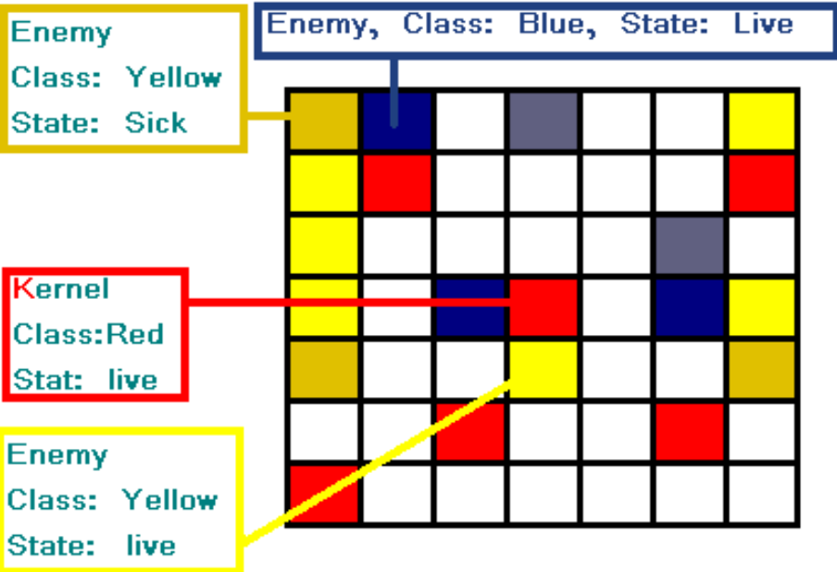
Figure 4.1 – Grid snapshot

Solution

The kernel is of class Red in state alive. (that is, type and class requirements are satisfied)
Lets look at the condition:

Red.alive[1-2] < enemy.sick[3]

There are three cells of class Red in state alive within 2 distance units from the kernel.
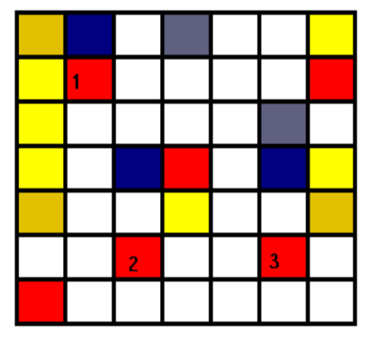
Figure 4.2

Looking at the right hand side, there are four cells that satisfy the condition as illustrated in Figure 4.3.
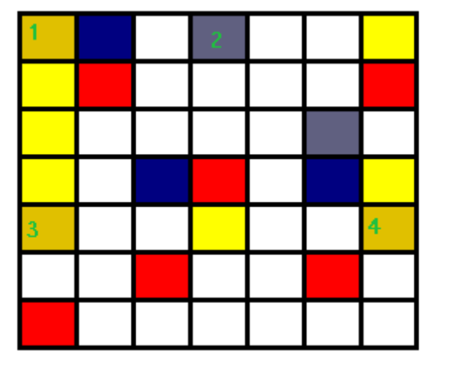
Figure 4.3

Since the condition is satisfied the transition will take place with a probability of 75% rendering the grid in the state shown in Figure 4.4.
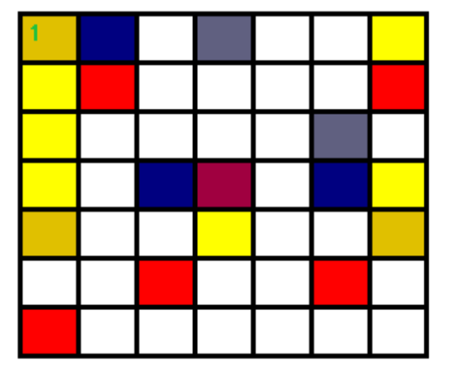
Figure 4.4

5 References
[1] http://en.wikipedia.org/wiki/Conway%27s_Game_of_Life
[2] EXGOL Language Reference Manual

